Below is Team 508’s WSB and associated Gantt Chart for the Spring 2025 semester. These include items mostly from the NASA Student Launch Handbook, however there are three key Senior Design Days that are listed and map on the bottom of the WSB and Gantt Chart respectively. Completing these goals will ensure the team has a successful launch of both the subscale and full scale vehicle before the required deadlines and that all NASA reports are completed and submitted on time.
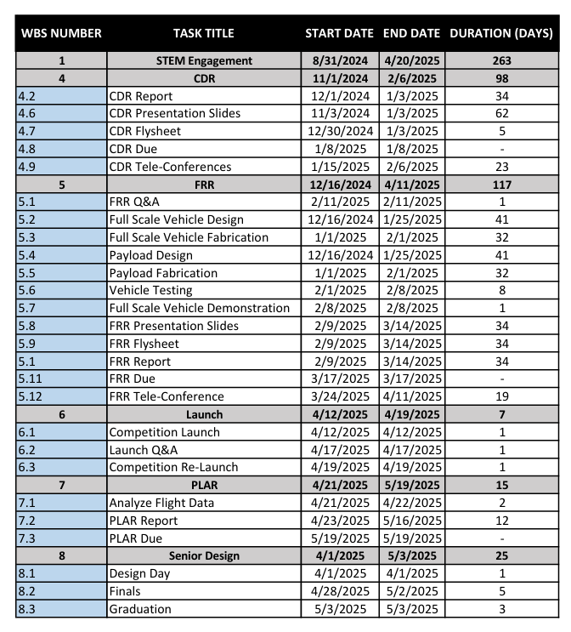
Figure 1.
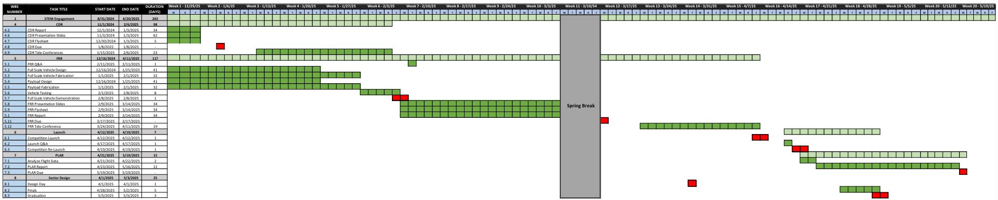
Figure 1.

